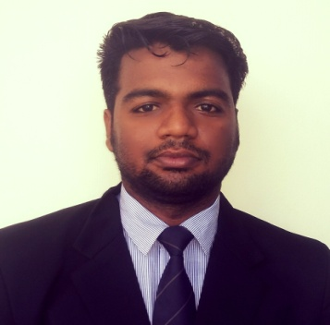
Name: Debasish Das
Email: debasishdas2070@gmail.com
Mob: 9178222194

CAREER OBJECTIVE
To obtain professional and financial heights, both for the organization and self, through skill and knowledge and learn from presents as well as establishment also..

QUALIFICATION SUMMARY

Qualification | College/Institutes | Board/  University | Year | Division
MBA | SRUSTI ACADEMY OF MANAGEMENT | BPUT, Rourkela | - | -
B.COM | Bhadrak Autonomous college ,Bhadrak | F.M UNIVERSITY | 2015 | 1st
+2 | Bhadrak Junior College ,Bhadrak | CHSE | 2012 | 1st
10th | Zilla School Bhadrak | HSC | 2010 | 1st

Skill Set
- Good skillset in MS-Office
- Good Communication Skills.
- Easily negotiate with other people.
- Can work effectively in team.
- Have good inter-personal skills.

ACADEMIC PROJECT

- SIP in Havell India.LTD on Market share of HAVELLS FAN.
- Financial Statement Analysis among the Reliance and ONGC.

TRAINING AND PROJECT

- One year training on PGDCA at SS INFOSYS, Bhadrak.

HOBBIES
- Love to Play Cricket.
- Listening Music.

EXTRA ACTIVITIES

- Participate in Business idea.
- Attended National Seminar on “Business Intervention For Inclusive And Sustainable Growth Intervention For IT , MARKETING, FINANCE & HR,” sponsored by AICTE in MBA 1st year.
- Have Visited “Odisha Milk Federation” to get an exposure to the corporate life and practical skill of field work

ACHIVEMENTS
- Champion in business idea .
- Participate in Inter college Cricket tournament.
- Secured 3rd place in 400mts Running.

PERSONAL PROFILE

NAME : Debasish Das
DATE OF BIRTH : 28thNov, 1994.
GENDER : Male
LANGUAGES KNOWN : English, Hindi and Odia.
PERMANENT ADDRESS : At/Po –Banka shai, Dist-Bhadrak, State – Odisha -756100

Place: Bhubaneswar
Date : signature

